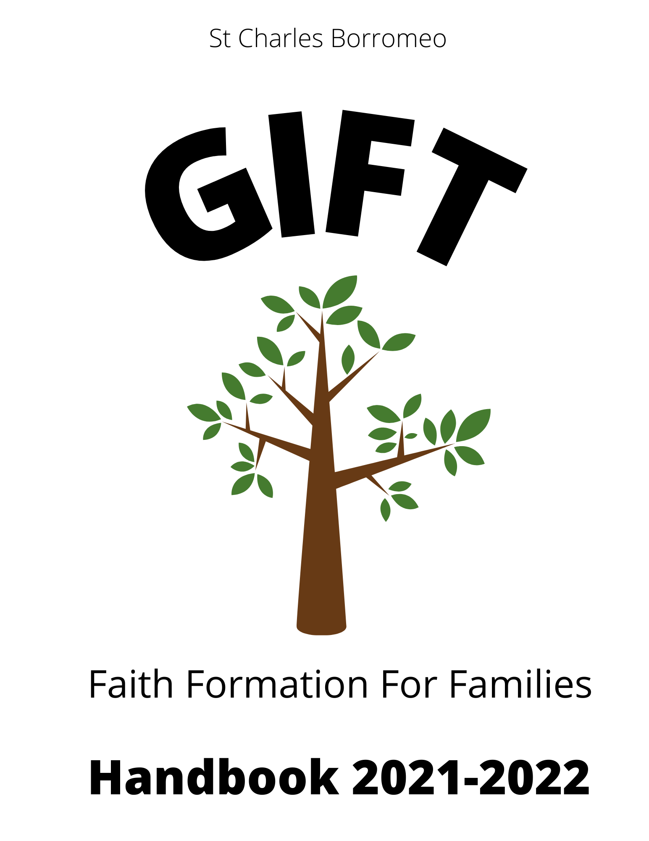

St. Charles Borromeo
Mass Schedule

Saturday: 5:00 p.m.
Sunday: 8:30 a.m., 10:00 a.m., 11:30 a.m.

Holy Days of Obligation: (check website or bulletin for Mass times)

Aug. 15, 2021 —Assumption of Mary
Nov. 1, 2021 —All Saints Day
Dec. 8, 2021 —Immaculate Conception
Dec. 25, 2021 —Christmas
Jan. 1, 2022—Mary, Mother of God
Easter Sunday - April 17, 2022
Ascension Thursday, May 26, 2022

Table of Contents

Welcome to GIFT 4
GIFT Requirements 5
GIFT Schedule 5
First Reconciliation 6
First Eucharist 6
Confirmation (GIFT 7/8) 8
RCL Benziger Family Life 9
Prayers and Concepts Children Should Know 10
Policies 13
Weather and Other Emergencies 15
GIFT Consent Form 16

Welcome to GIFT

Welcome to Religious Formation at St. Charles Borromeo Church, a Roman Catholic Church in the Diocese of Metuchen. We call our religious formation program GIFT, which stands for Growing in Faith Together. We believe that faith formation is a life-long process and we are always growing in our faith.

GIFT is an intergenerational faith formation program where parents and children of all ages come together to pray and learn together. We use an intergenerational format because faith formation is different than academic learning. Faith formation happens in a community of believers and it is passed from one to another. For children, exposure to a wide range of people of faith is ideal for growing in their own faith. Our hope is that at each GIFT session, everyone present, children and adults, will share faith so that all children can benefit. Intergenerational faith formation can be a very powerful experience, but it does take everyone’s participation.

Our theme for GIFT 1-6 this year is Jesus Lives (the Gospel story). During this year we focus on the life, death and resurrection of Jesus. Our Confirmation youth will experience an overview of the Catholic faith, especially focusing on the pillars of Catholicism.

Throughout the year, we invite you to visit our website often (www.borromeogift.org) and be sure to read the weekly emails sent to all registered GIFT families. This is how you will find the latest information to help you prepare for the GIFT sessions, information about our Sacramental Preparation programs and many Catholic resources to help you and your family on our faith journey.

GIFT Requirements

Each month families are required to attend weekly Mass and complete all assignments. Children preparing for the sacraments have additional requirements as outlined in this book.

GIFT Schedule

The GIFT schedule is available online at www.borromeogift.org under GIFT Schedule. Please note that we have a weekly format. Some sessions will be in person and some will be done at home. This weekly format should make it easier for families set aside time each week to commit to religious formation. Make a family commitment to your child’s faith formation! Children who miss more than 2 assignments will not progress to the next level. Please note that children preparing for Confirmation must be in religious formation continuously after the Sacrament of First Eucharist. There are no exceptions to this requirement.

Children in grades 1-6 participate in GIFT 1-6, while those in Confirmation preparation participate in GIFT 7/8. Both are family formation models and parents are the main catechists. No worries, you will be guided and completely supported!

First Reconciliation

Children who have completed at least one year of religious formation may prepare for Sacraments of First Reconciliation and First Eucharist.

The Sacrament of Reconciliation celebrates God’s unconditional love for us and reminds us that we are all called to receive God’s merciful forgiveness. Celebrating this sacrament should give us the hope and the courage to turn away from our mistakes and our failures to love and to start again.

Basic Concepts of Reconciliation

- God loves us no matter what we have done.
- All of us do things that somehow hurt others.
- When we hurt other people we turn away from God.
- God is always waiting for us to turn away from things that are not good by turning to God.
- It is through Jesus that we know of the Father’s love.

First Eucharist

Through the Eucharist, we are called to the Table of the Lord. The Eucharist, the source and summit of the life of every Catholic, is the great gift of God’s true loving Presence. Eucharist is the essence of our life as disciples: a life of communion with God and of solidarity with one another. There are two parts to readiness for participation in the Eucharist:
1. Your child must know that this bread and wine have become the Body and Blood of Jesus Christ - that Jesus is truly present.
2. Your child must have sufficient preparation to allow for reception of the Eucharist with appropriate devotion and reverence.

It is important for your child to know and understand that since the Church is God’s home it requires a respectful attitude at all times Some basic concepts to review with your children include the following:

- It is appropriate to bow toward the altar when entering or leaving our pew to show respect for God.
- All must listen attentively to God’s Word being proclaimed during the celebration of the Mass.
- We all must actively participate in the celebration of the Mass by saying the prayers and singing.
- We must approach and leave the altar with a prayerful, respectful attitude.
- It is inappropriate to leave Mass to go to the bathroom unless absolutely necessary.
- The Blessed Sacrament is reserved in our chapel. It is appropriate to genuflect before the Blessed Sacrament when entering or leaving the chapel.

Preparation for the Sacraments of First Reconciliation and First Eucharist will begin in January. Preparation will include 4 sessions and a retreat for First Reconciliation. After the celebration of First Penance, we will then have 4 preparation sessions and a retreat for First Eucharist. Sessions typically take place on Sunday mornings while the retreat is usually on a Saturday morning.

Confirmation (GIFT 7/8)

Through the Sacrament of Confirmation, we are called to Confirmation, together with Baptism and Eucharist, constitute a process by which the Spirit brings the believer to full union with the community. Youth who are at least in grade 7 and have been attending Religious Formation may begin preparation for Confirmation. Families should understand that preparation for Confirmation is a commitment that should be considered a priority. If a family cannot commit to the required sessions, the child should wait until a later date to celebrate the Sacrament of Confirmation. It is in the child’s best interest to be fully present to the preparation or to wait until a later, more convenient time to celebrate the sacrament.

Youth in grades 7 and 8 also participate in weekly sessions. Some will be in person and some are home assignments. Anyone who wishes to be confirmed must complete all assigned tasks.

We work in collaboration with the Center for FaithJustice to provide a hands-on Confirmation preparation summer experience. During the summer following 8th grade, each candidate attends a week long program of formation and service (ServiceworX) specially developed for confirmation preparation. Each day consists of service at various service sites selected and approved by the Center for FaithJustice and the Religious Formation office and confirmation preparation. The program runs from Sunday morning to Friday. A meeting will be held in the fall with more information and details.

The schedule for Confirmation preparation (GIFT 7/8) is available at www.borromeogift.org under the GIFT schedule.

RCL Benziger Family Life

As a way to support the Church’s teachings on family life education, we are pleased to present the RCL Benziger Family Life program to all youth in our GIFT program.

RCL Benziger Family Life helps to foster personal growth, Catholic moral development, and respect for life. Centering on five themes of God’s gifts – family, self, life, love and community – the program at each grade level helps families to see, internalize and act upon values for Catholic family living.

Prayers and Concepts Children Should Know

Teaching Your Child to Pray
It is important for every child to learn how to pray. Children mainly learn to pray
by watching and copying their parents, siblings, relatives, others in church and
elsewhere.

1. There is no wrong way to pray  The focus isn't so much “saying our prayers” as it is “talking with Jesus.” So beyond memorizing prayers, let your child know that they can speak to Jesus as a friend. Let them know that they can tell him anything: silly things that happened that day, things they are scared of, what they hope for, people they are worried about, etc. Invite your child to pray with you, but let them know he or she can pray whenever they want to by themselves - in bed at night, after they wake up in the morning, while they are walking to or from school alone, or riding to soccer practice, etc.  2. Don’t ask your child to do something which you aren’t doing yourself  Occasionally mentioning something you have prayed for is a great way to witness to your child. For example, when they have finished telling you about something good that happened to them at school you might be able to say “Wonderful! I prayed last night that you would have a good school day today!” If you know they are worried or scared about something, you can offer to pray for them or with them about it. Saying something as simple as “Jesus, help Jane to be brave at the dentist tomorrow even though she is scared about getting her tooth pulled out” can be consoling for her.  3. Regular household prayer is a great model  Try praying before meals, in times of crisis, at bedtime, in the car, with the Bible, or after a good thing happens. Let them see that praying can be natural and informal – it doesn't have to be intimidating and they don't have to worry about doing it “the right way.” Jesus knows the good intentions in our heart and hears us regardless of how sophisticated our words are. |  |  | 3. Regular household prayer is a great model  Try praying before meals, in times of crisis, at bedtime, in the car, with the Bible, or after a good thing happens. Let them see that praying can be natural and informal – it doesn't have to be intimidating and they don't have to worry about doing it “the right way.”  Jesus knows the good intentions in our heart and hears us regardless of how sophisticated our words are. Weave prayer into your daily life.

(Prayers can be found online at http://www.loyolapress.com/traditional-catholic-prayers.htm)

By First Level of Faith Formation (usually Grade 1)
It is important that parents begin teaching children how to pray as early as possible – even before they know how to talk! This will insure that prayer becomes a regular part of life. A wonderful practice for parents to help children learn how to pray is to pray together each night before bed. By praying together each night, children will know their prayers and develop a lasting relationship with our loving Father. Young children should know:
- The Sign of the Cross
- The Lord’s Prayer
- The Hail Mary
- Glory to the Father

By Second Level of Faith Formation
In addition to the prayers above, children preparing for the Sacraments should know all of the above and:
- The Act of Contrition
- How to say grace before and after meals

By Third Grade

By third grade, children will be very familiar with all of the above and:

Parts of the Mass

Parish Reconciliation Services at least once per year

Prayer in their own words, especially prayers of petitions for the needs of others.

By Fourth Grade

By fourth grade, it is important that children know the basic prayers above and be familiar with the basics of our Catholic faith including:

The Nicene Creed (a simple way to do this is to attend Mass each week)

The Ten Commandments

The Beatitudes

The Spiritual and Corporal Works of Mercy.

By Fifth and Sixth Grade

In addition to all of the above prayers and Catholic basics, children in fifth and sixth grade should know:
- Seven Sacraments
- Seven Gifts of the Holy Spirit

Policies

Registration and Fees
The fee for Religious Formation at St. Charles is $300 per family per year. This is for all families with children in grades 1-7. This will be due at the time of registration. Payment can be either by check made out to St. Charles Borromeo with Religious Formation in the notation line, or made through Faith Direct.

Families with children in the 8th grade will pay $300 when you register for the week of ServiceworX in the fall. This is a requirement for Confirmation and payment will be separate. More details will be available at the fall information session.

Commitment
Registering in our community’s Religious Formation programs demonstrates that you have made the religious formation of your family a priority over the many activities that are available to families in our area. Your commitment to the religious formation of your child is also evidenced by your regular attendance at Mass and participation in the St. Charles Borromeo community and your commitment to GIFT and Sacramental Preparation sessions and assignments.

Attendance
Attendance at all GIFT sessions and Sacramental Preparation sessions is essential to a solid faith formation background for all of our youth. Youth must always be accompanied by a parent. All home assignments are meant to be done with parents. There are no exceptions to this policy.

Discipline
Mutual cooperation and respect for all at any gathering is essential for effective learning. It is important to remember that we are communicating Christian values to our children. Parents should remind children that proper behavior is expected during all session especially when we are divided by age groups. Children should always be accompanied to the restrooms and should be reminded to use the restroom before the session so that valuable time is not wasted.

For online meetings, all children MUST be accompanied by a parent. All must be appropriately dressed and must be in a public place in your home (not on a bed). Zoom meetings will not be recorded but a recorded webinar or some other platform will be provided if you must miss the live session.

Child Protection Policy
- Children cannot be left unattended at any time.
- No adult is ever to be alone with any child other than his or her own child.

Special Needs
If a child has special needs, parents/guardians are asked to share that information with us so that we can work together to meet the needs of the child.

Crisis Management Plans and Drills

For the safety of our families, The Catholic Community of St. Charles Borromeo has in place policies for lockdown, evacuation and fire drills. More information at our first GIFT session.

Illegal Substances and Weapons

Drugs, alcohol, tobacco, and weapons of any kind are not allowed on parish premises at any time. If anyone is found in possession, the person will be detained until proper authorities are notified.

Weather and Other Emergencies
If GIFT or a Sacramental preparation program is cancelled, there will be a message on the St. Charles Borromeo answering machine and a message posted on the St. Charles Borromeo web page. Please see www.borromeo.org.

GIFT Consent Form

I have read the GIFT Handbook and I understand all of the information stated in it.

I agree to follow all policies stated in the handbook and understand my responsibilities as a GIFT parent.

Parent/Legal Guardian Name:________________________________________________

Parent/ Legal Guardian Signature: ____________________________________________

Date:___________________________

